# Name ______________________________ Block ___

**Unit 8 Review/Study Guide**

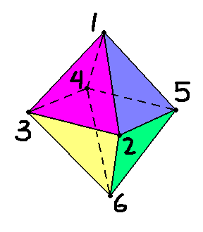

1. A plane slices through vertices numbered 1, 3, 6 and 5.
2. Draw the cross section.
3. Indicate another possible plane by drawing on the octahedron, and then draw the cross section.
4. A Standard soup can has a diameter of 10 cm and a height of 15 cm.
5. How much soup will fit within the can?
6. How much tin is required for the can?

1. Assuming no overlap, how much paper is necessary for the label?

1. A standard girls’ basketball has a diameter of 28.5 cm
2. How much leather is required to make the ball?

1. How much air is needed to fully inflate the ball?

1. A metal cylinder with radius 3 in. and height 12 in. is melted and recast into a cone with radius 9 in. How tall is the cone?

1. 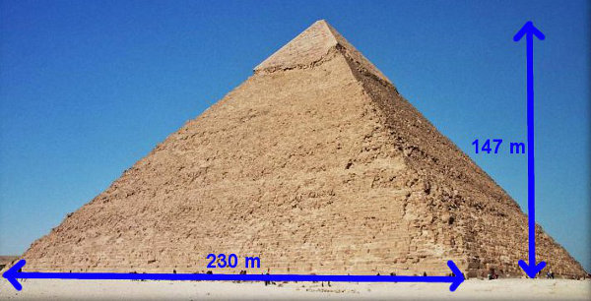One of the Egyptian pyramids has a square base with 230 m along the base and 147 m high. What is the volume of the pyramid?
2. William filled a rectangular tank with 8.0 inches of water. He then dropped a rock into the water. When it was completely submerged, the water level in the container raised 2 inches. Show all work to find the volume of the rock.



V = _____

1. 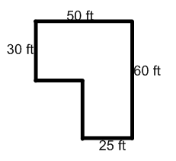The diagram to the right is of a driveway made from 6 inch thick concrete. (Remember: 1 foot = 12 inches)
2. Find the total length of lumber required to make the forms. (Perimeter)

1. What is the volume of the concrete needed for this driveway?

1. What would be the total cost if the concrete costs $104 per cubic yard?

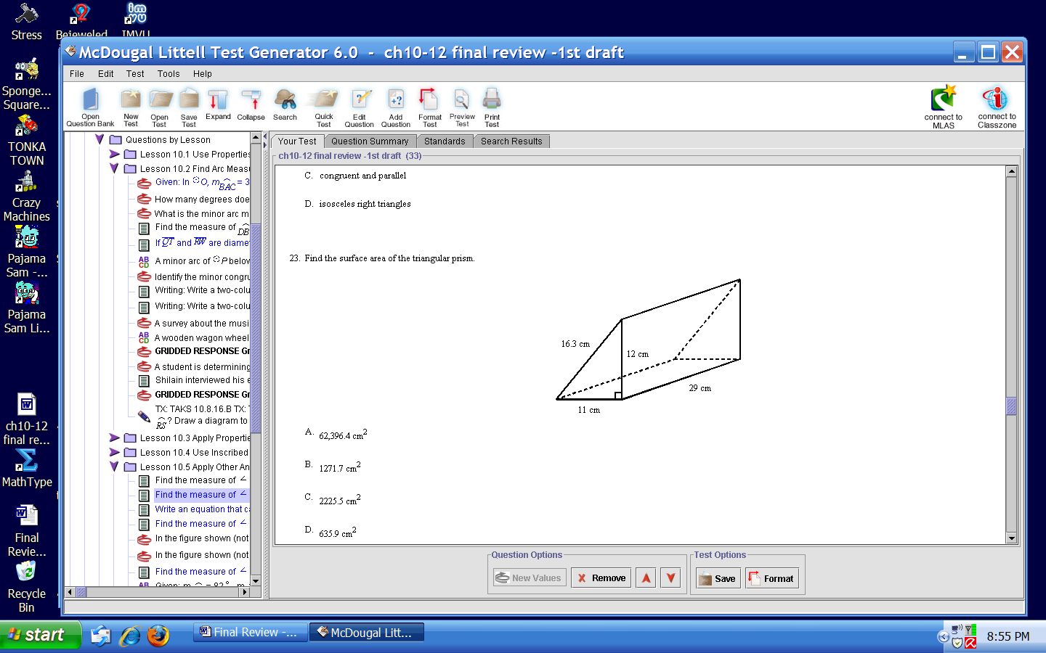8. Find the surface area of the triangular prism.

12 cm

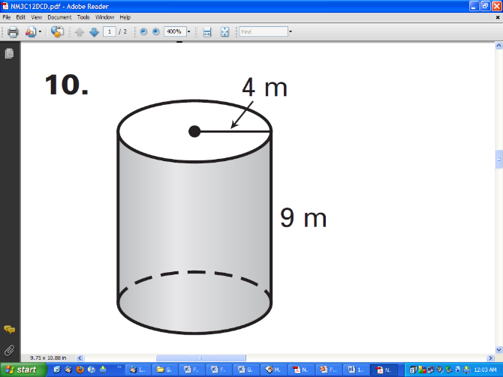

7 cm

9. The surface area of the right cylinder is:

10. The pyramid below has a square base and a slant height of 7ft. Find its surface area.

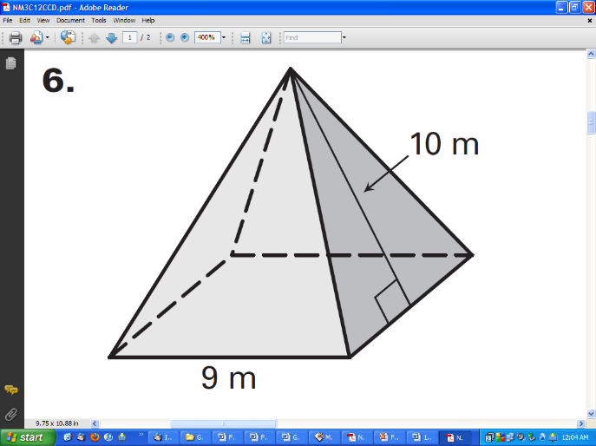

5 ft

7 ft

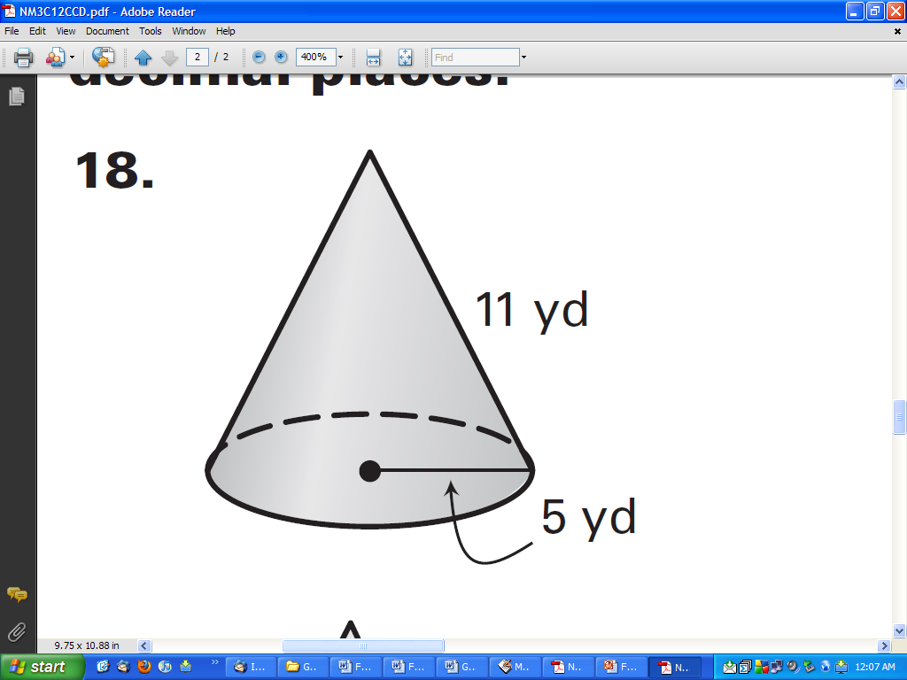

4 in

7 in

11. The surface area of the right cone is:

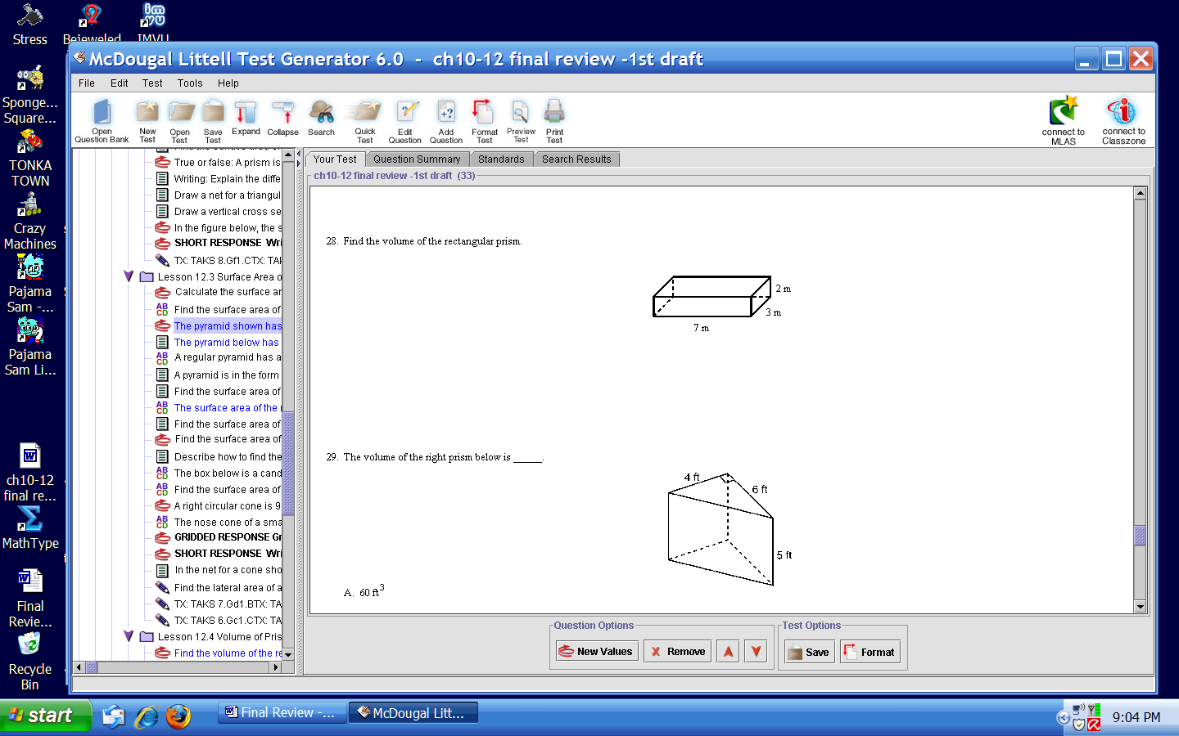12. Find the volume of the rectangular prism.

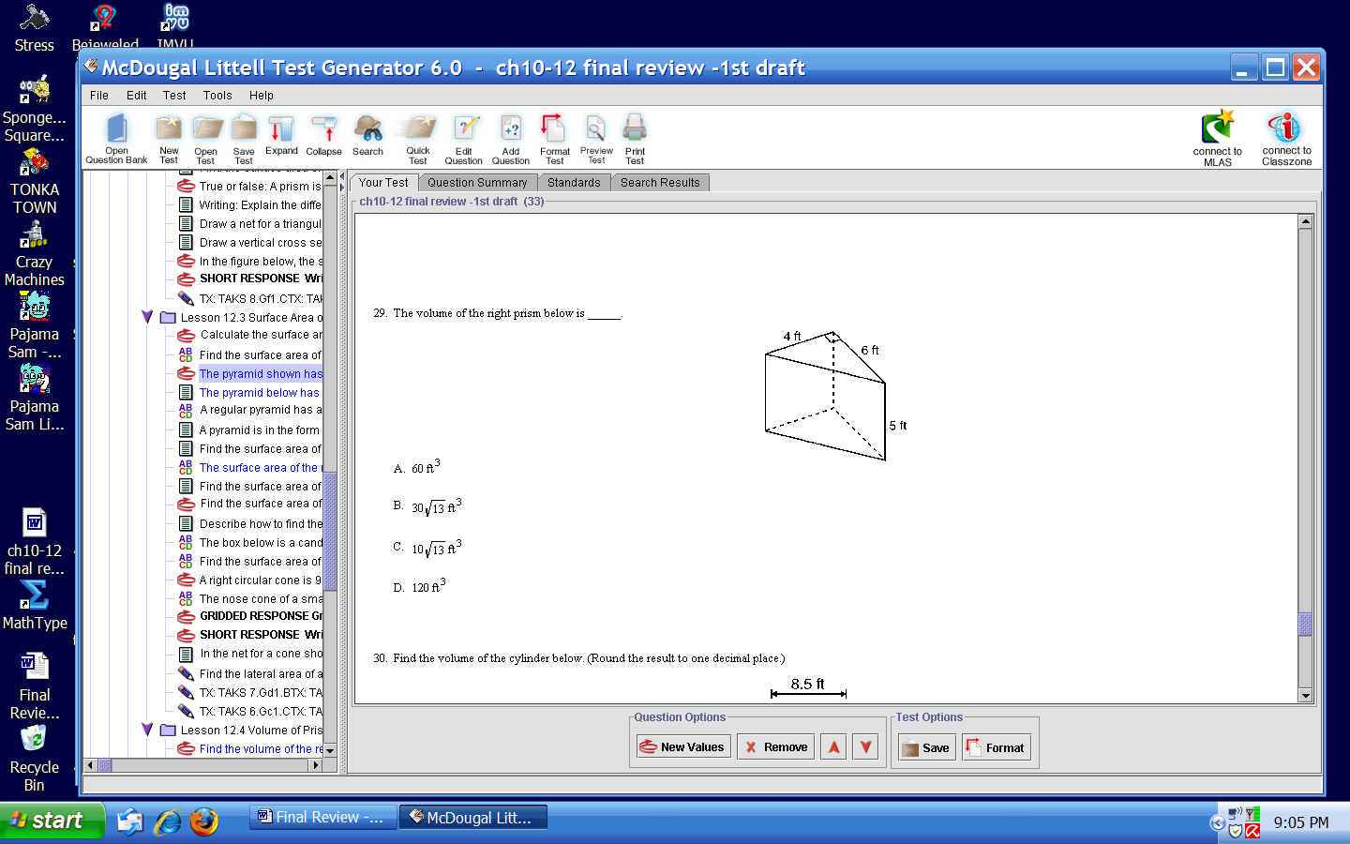

13. The volume of the right prism below is:

14. Find the volume of the cylinder. Leave answer in terms of.

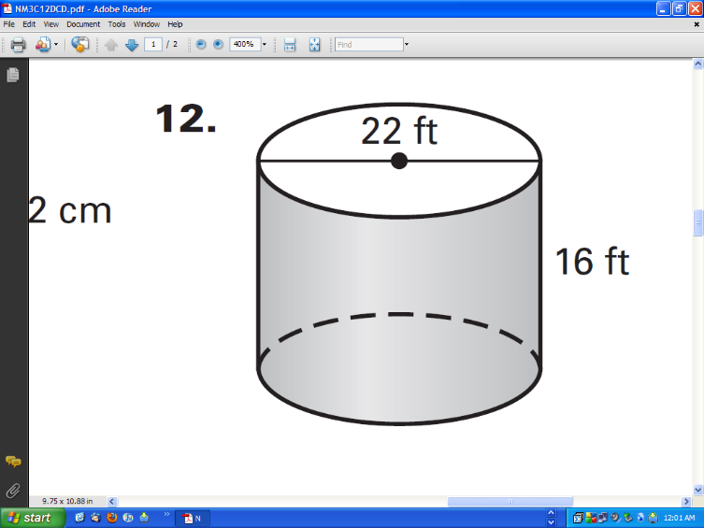

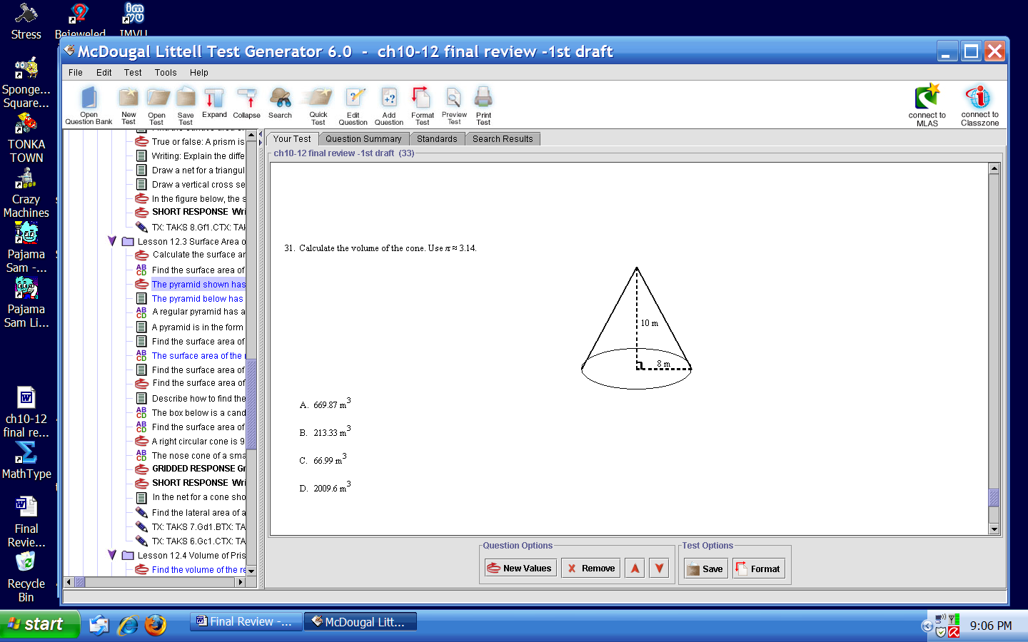15. Calculate the volume of the cone. Leave answer in terms of.

16. Find the surface area of a sphere that has a diameter of 10cm. Leave answer in terms of.

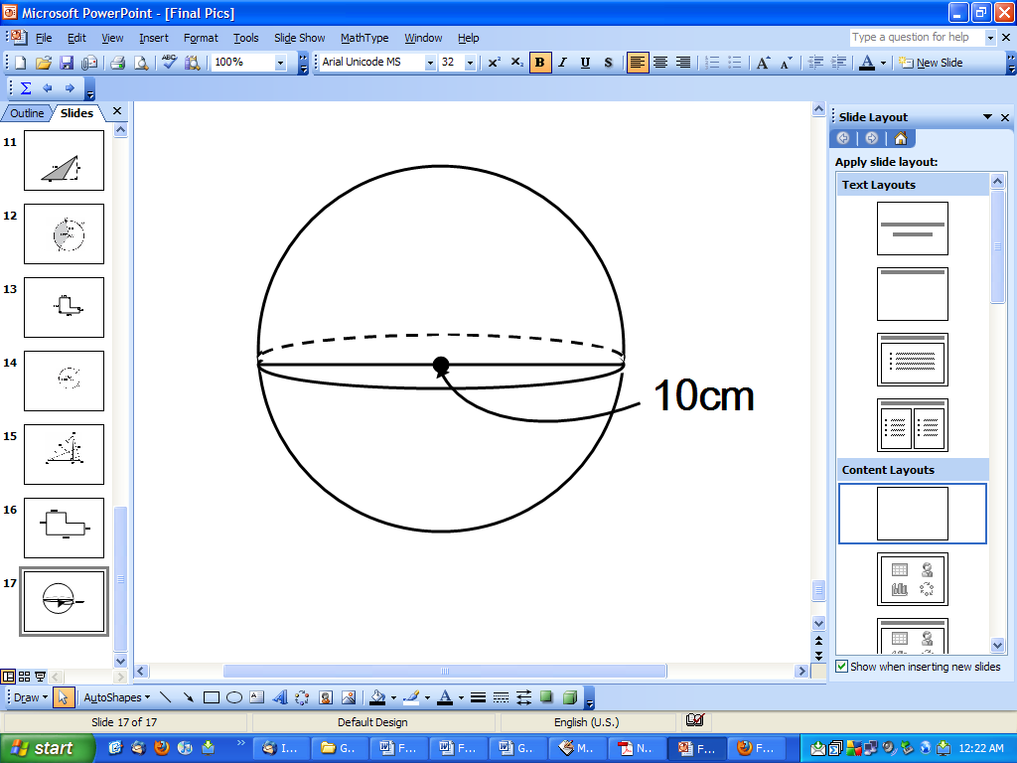

17. Find the volume of a sphere 8in. in diameter. Leave answer in terms of.

